How to Vote From Abroad
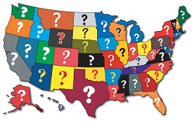
KNOW YOUR VOTING STATE - Determine the state and address of your last U.S. residence – this is your state of legal voting residence. You do not need to have any existing relationship with this address and it can even be an address that no longer exists!

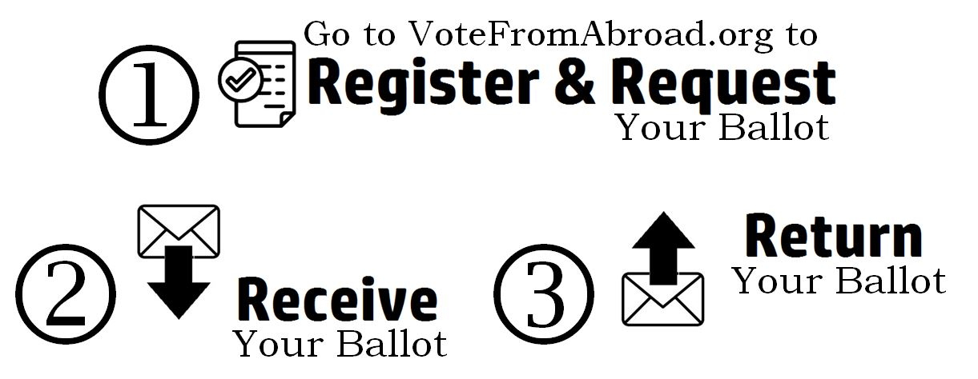
1 REGISTER & REQUEST YOUR BALLOT - You must register with local election officials in your state of legal voting residence AND each year request an absentee ballot. You can use the Federal Post Card Application (FPCA) as a simultaneous voter registration application and absentee ballot application. This is the official form that is provided through votefromabroad.org which also gives you customized instructions and deadlines for submitting your application. Depending on your state, you may be able to return your signed FPCA by email, instead of postal mail.
2 RECEIVE YOUR BALLOT - After submitting your application, you will receive your ballot from your local election officials. It may be provided to you by email or postal mail.
3 RETURN YOUR BALLOT - Once received, you will complete your ballot and return it to your local election officials. You may be required to submit your ballot by email or postal mail.
What if I do not receive my ballot?
You may use the Federal Write-in Ballot (FWAB) to cast your absentee ballot, register to vote or request future absentee ballots. You may complete a FWAB even if you ultimately receive and complete your official absentee ballot. If your local elections officials receive both, they will not count it as duplicate or invalidate your vote.
Questions? Contact us at help@votefromabroad.org or online chat at votefromabroad.org

