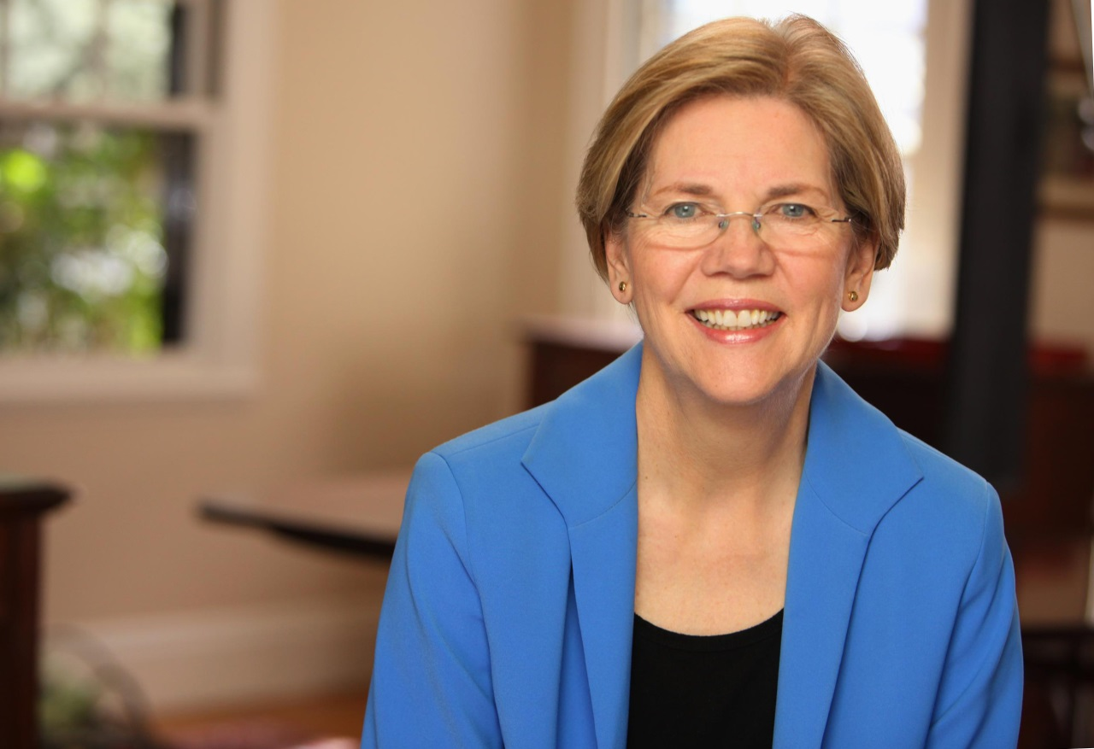



**Drinks & American politics**

**Watch party: ELIZABETH WARREN**

sunday, sept 17  
8 pm – 10:30 pm  
Beijing

Beersmith Gastropub   
@ Hotel Jen Beijing // 新国贸饭店 Entrance on Guanghualu, across from Kerry Center