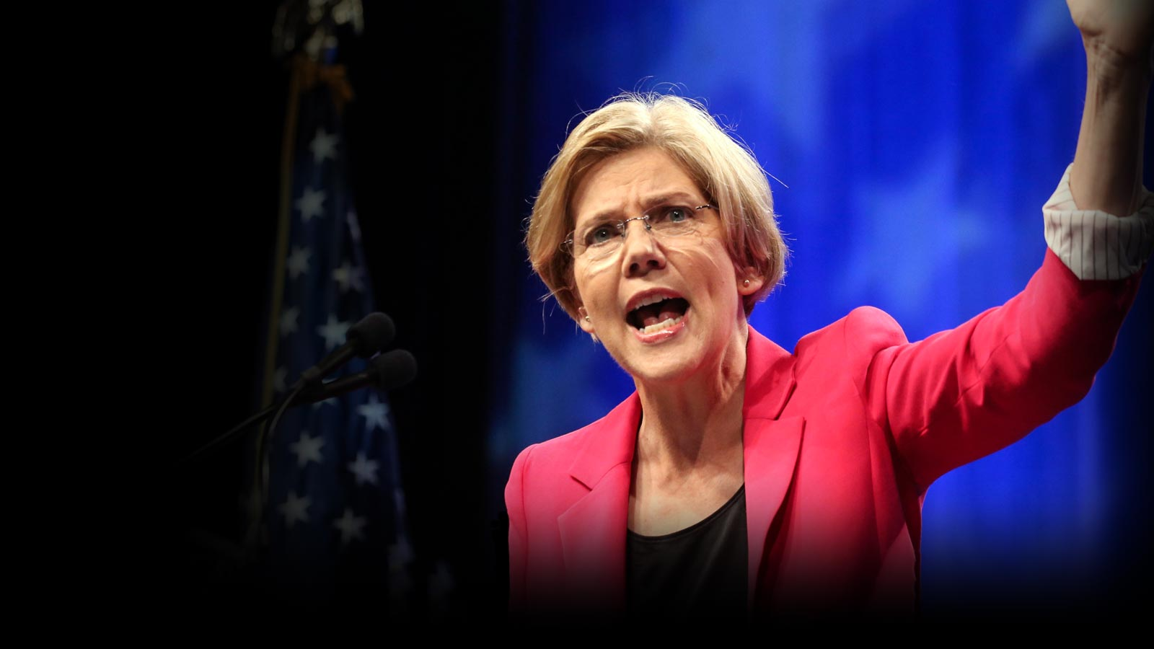

**Drinks & politics**

**Watch party: ELIZABETH WARREN**

sunday, sept 17  
8 pm – 10:30 pm  
Beijing

Beersmith Gastropub **@ Hotel Jen CBD**  
1 Jianguomenwai Dajie, 1st FL, Chaoyang   
朝阳区建国门外大街1号新国贸饭店一层



**Drinks & politics**

**Watch party: ELIZABETH WARREN**