Democrats Abroad China Leadership Board Meeting
Tuesday, November 21, 2017 (7:00-8:00pm)
WebEx Meeting Number: 856 559 172 (Password: dems)

Notes from Last Meeting: Meeting Notes - DA Leadership Meeting, 2017.10.22
Aaron Kruse, Chair - present
Samantha Wong, Vice-Chair - present
Elizabeth Jenkins, Secretary - present (notetaker)
Jim Spear, Treasurer - present
Randi Miller, Legal - present
Kira Leinonen, Comms/IT - present

James Flanagan, At-Large - present
Phong Quan, At-Large - present
Faith Gary, At-Large - present
Joshua Lally, At-Large - absent
Chris Zombik, At-Large - present
Ada Shen, Ex Officio - present
Rich Welch, Ex Officio - absent

Recent Happenings
OCT 23 | Sent 1761  Opened 208 (11.81%) 12 (0.68%) | Email | If we don’t fight. | Elizabeth
OCT 25 | Aaron, Sam, Ada | AP Regional Call |  | Shaun
OCT 30 | Sent 1748  Opened 239 (13.67%)  Clicked 10 (0.57%) | Email | First Charges. | Elizabeth
NOV 4 |  | Online Town Hall | President of Emily’s List | Women’s Caucus
NOV 5 | 5 attended | Book Club | HRC’s What Happened | Emily
NOV 6 | Sent 1743  Opened 275 (15.78%)  Clicked 14 (0.80%) | Email | Unity. | Elizabeth
NOV 8 |  | Online Town Hall | James Carville | DA Global
NOV 12 | 10 attended | Meetup | Shanghai | Sam
NOV 12 | 5 attended | Meetup | Beijing | James B.
NOV 12 |  | Web Post | October 2017 Happenings Around China | Elizabeth
NOV 13 | Sent 1727  Opened 237 (13.72%)  Clicked 6 (0.35%) | Email | Celebrate! | Elizabeth
NOV 13 |  | Web Post | Celebrating Foy's Victory in Our Sister District | Elizabeth
NOV 20 | Sent 1726  Opened 244 (14.14%) Clicked 24 (1.39%) | Email | Thankful. | Elizabeth

Meeting Notes
- Attendance - Elizabeth, noted.
- Review and approve previous meeting notes. - Aaron, voted and approved.
- Update from the Chairs - Aaron.
  - Events since last meeting - Book club, meetups
  - Ada proposing that DA Global use DA China to pilot a more CC-centric Voter Reg (Ballot Request, Return) operating model for 2018.
  - Final draft of financial procedures - Jim, ExCom voted and approved.
  - Action Items from last time -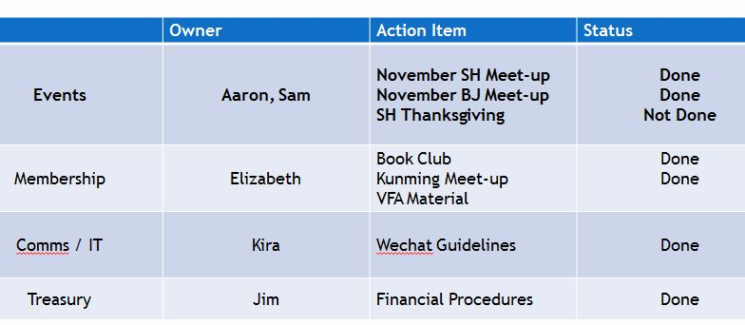
  - Upcoming events -
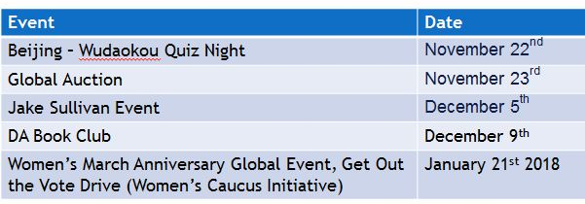
    - Quiz Night - Nov 22 (sponsored by Josh) - We’ll ask questions about politics
    - Global Auction - Nov 23 - Elizabeth donated a virtual tour of Forbidden city.
    - Jake Sullivan Event - Dec 5 - DA China 35-70 tickets. Yale Center Beijing. AmCham China also helping organize.
    - DA Book Club - Dec 9 - Hosted by Brian in Kunming.
    - Women’s March Anniversary GOTV drive - Jan 21
- Membership Committee Update - Elizabeth
  - Recruitment picked up with sharing on Gabby’s US Abroad wechat group.
- Comms/IT - Kira
  - What we’re reading - schedule. - Kira proposed and will followup.
  - New WeChat Group for Beijing. - Discussed and comms committee will execute.
    - Question (Randi): Why no Beijing WeChat group? Maybe not necessary. Could poll the chat group.
    - Chris - Maybe Beijing doesn’t have a community group. But that could maybe foster offline events. Well noted.
    - Comms Committee will organize a new Beijing wechat group.
  - Subreddit - Aaron is going to start that eventually. Might help manage longer conversations.
- Open Floor
  - Sam -
    - Membership engagement and attendance is very healthly: Boosted membership with sharing via related WeChat groups (Gabby’s US Abroad and Thunderbirds). Thanksgiving event has 21 people signup.
    - Plan to have a GOTV event on Jan 21 in Shanghai, in coordination with the women’s caucus.
      - Kira - can we plan solidarity events with back home? Ada - Intl is looking at coordination but some unspecified concerns.
      - Randi - maybe we could have a speaker? Aaron - How about HRC?
    - Women’s Caucus calendars bought and can be resold. - Sam will followup.
  - Elizabeth -
    - January will also mean we have 1000 members expiring.
    - Tactic for verifying members - click email to self-verify. Trialed on last email. Good response (18 clicks!).
- Next meeting: Dec 17 at 7pm
- Farewell - Happy Thanksgiving!
(❦Big love fest touched off by Aaron voicing his gratitude for being involved in DA. Everyone agreed. I think.)

