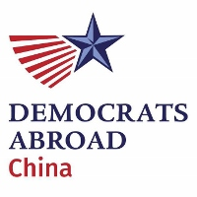
2019 Annual General Meeting
  - Meeting locations in Beijing and Shanghai linked via WebEx.
April 14, 2019
- Welcome
  - Called to order by Aaron Kruse, Chair of Democrats Abroad China
  - Attendance check. Quorum met.
  - Approve previous leadership monthly meeting minutes.
- Introduction to Democrats Abroad
  - Democrats Abroad is the official Democratic Party arm for the millions of Americans living outside the United States.
  - Who is DA China?
    - DA China – born 2017
    - Volunteers
    - Active at all levels
- Year in Review – since our last AGM
  - At global meeting in Tokyo, China had three reps in-person (Aaron Kruse, Elaine Kim, and Chris Zombik)
  - We had the chance to meet with the US Ambassador to China from Max Baucus (from MT, now replaced by Terry Branstad from IA), even gave he and his wife DA China t-shirts.
  - We dedicated a lot of volunteer hours to helping Americans vote from China. We had a solid presence at our usual expat venues leading up to 2018 elections.
  - We also organized great social events, including watching returns from the 2018 elections. Nice to have something to celebrate.
- Membership Update (Elizabeth Jenkins, Secretary)
  - Introduction to the role of Secretary
    - Ongoing: Confirm new members, Contact existing members
    - Annually: Review lapsing membership records, Certify official count of members
  - Official Membership Count

532 new members
At least 76 reactivated or transferred from other
2227 database became members before May 6, 2017
2740 database total on 4/13/2019
789 expired since 2017
  - New Members Joined per Month
  - Official Member Count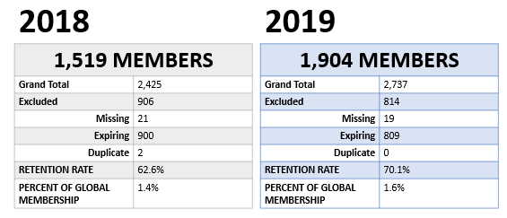
  - Why does this matter? It helps determine our level of influence (voting reps) within the DA global structure.
    - DA currently reserves 25% of its DPCA Voting Member slots to provide 1 to each Country Committee. The other 75% of the DPCA Voting Members allocated to CCs are distributed proportionally based on verified membership numbers.
  - Compared to all other 54 other country committees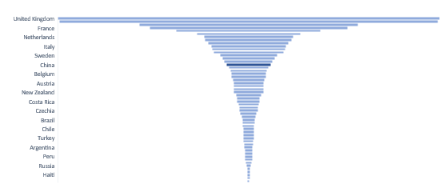
  - Zoom in to the top 20 – China is #17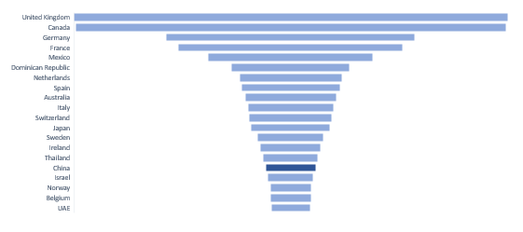
  - Growth on WeChat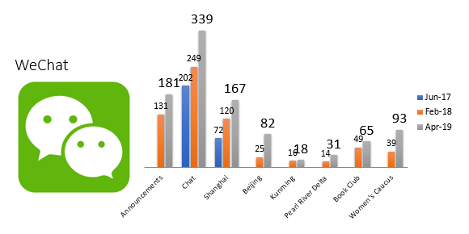
- Election of Leadership Board for May 2019-May 2021
  - NEC member presiding over voting and tallying: Melinda Yang
  - Part 1: ELECTING 11 LEADERS FOR BOARD
    - Floor Nominations - none
    - Candidate Speeches (alphabetical by first name)
      - Aaron Kruse
      - Alexander Lee
      - Brian Kloosterman
      - Brittni Young
      - Christopher Zombik
      - Devika Koppikar
      - Eileen Walsh
      - Elaine Chow
      - Elizabeth Jenkins
      - Faith Gary
      - Justin Fischer
      - Kim Wong
      - Nicholas Bonvini
      - Nicholas Gowan
      - Patrick Cranley
      - Sarah Kimmet
    - Time allotted for voting, close polls, tally of 54 voters, and announced top 11 vote winners. These candidates all won at least 50% of the vote (at least 27 voters included them in their ballot):
      - Aaron Kruse
      - Elizabeth Jenkins
      - Elaine Chow
      - Kim Wong
      - Faith Gary
      - Alexander Lee
      - Sarah Kimmet
      - Eileen Walsh
      - Justin Fischer
      - Patrick Cranley
      - Devika Koppikar
  - Part 2: OFFICER ELECTIONS (order: Chair, Vice Chair, Treasurer, Secretary, Legal Counsel, Communications)
    - For each position: Determine candidates, Candidate Speeches, Time for vote, close poll, tally and announce for each office. Run-off if needed
    - Chair: Aaron Kruse (ran and won unopposed)
    - Vice Chair - Elizabeth Jenkins (ran and won unopposed)
    - Legal Counsel - Alexander Lee (ran and won unopposed)
    - Treasurer - Patrick Cranley (received 18 of 26 votes, Kimberly Wong also ran)
    - Secretary - Kimberly Wong (ran and won unopposed)
    - Communications Director - Elaine Chow (received 11 of 21 votes, Justin also ran)
- Congratulations and closing

