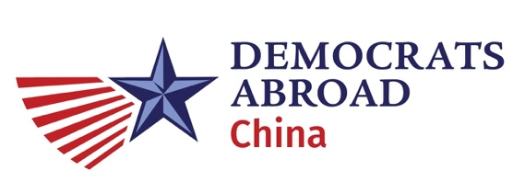
These meeting minutes were approved on November 15, 2020.
These meeting minutes submitted to the leadership board and posted to wiki by the DACN Secretary, Elizabeth Jenkins. Additional reports and documents posted as well.

These meeting minutes shall be reviewed, corrected, and approved at the next meeting on November 15, 2020 at 8:00 pm (CST).

At a regular monthly meeting of the China country committee leadership board of Democrats Abroad, held on the 18th of September 2020 at 8:00 pm (CST), via Zoom video conference, the Chair presiding, the reading of the minutes by the Secretary was dispensed with (historically notes have been reviewed and approved outside the meeting).
Meeting called to order at 8:06 pm. Six members of the leadership board were in attendance, with 4 members from the ExCom. Quorum was met and the online video meeting was recorded.
The meeting minutes for our last meeting on the 13th of September 2020 were approved.
Reports presented – see slide deck, except where noted below.
- Chair’s Report – Kim Wong
  - Great work in September! >1000 users,
ACTION: Elizabeth share data with Elaine.
- Treasurer’s Report – Justin Fischer
- No Membership Report by the Secretary – Elizabeth Jenkins
- No General Counsel Report – Alexander Lee (joined late)
- Communications & IT Report – Elaine Chow
  - Last Chance graphic… but soon out of date.
  - Fielding voting questions on DA China account.
  - Shanghai fundraising during election watch. Also locations in Shunyi, Beijing, Kunming. Wednesday morning/evening… commisserate/celebrate. Reporters present.
- DA China GOTV Voter Help – Devika Koppikar
  - Same questions over and over.
  - Alexander: feedback on voter reform? Elaine: DA has participated in legal. Kim: next meeting.
- Caucus Report – Kim
  - AAPI decompression event in December in Shanghai.
- Phone Bank Training – Eileen
  - Updated script and recoding info. Confusing changes. Kim: email the CallHub team.
- Fundraising – Jacob
  - Kim: new donations? Justin: 3 new donations as reported in treasurers report.
- New Business
  - Alexander: lack of uniformity of voting rules. Justin also interested.
  - Kim: Faith suggested a survey. Elizabeth what is actionable?
  - Kim: after the election, we should address the open seat on the board. Eileen: can I suggest? Kim: Yes see if anyone is interested. Alexander: someone who can cover caucuses? Kim: potentially.
- Upcoming Events
  - Plans sent to Elaine?
- Open floor
  - Joe Biden townhall was good. Relaxing.
  - Alexander: Promoting senate seats? Elaine/Justin: GOTV focus. Elaine: Can share the materials already created for Global.
Next meeting scheduled.
Meeting adjourned at 8:46 PM and the next meeting will be on November 15, 2020 at 8:00 pm (CST)

