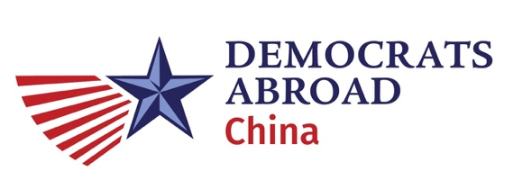
Notes approved (with correction) at 7/19/2020 Leadership Meeting. – Elizabeth Jenkins, Secretary
Sunday, 2020.04.26 DACN Leadership Meeting Minutes.
Attendees (noted by Aaron): Aaron Kruse, Alexander Lee, Eileen Walsh, Elaine Chow, Justin Fischer, Brittni Young, Patrick Cranley, Devika Koppikar, Elizabeth Jenkins, Kim Wong
Meeting Minutes
Mar Meeting Minutes - Approved
- GOTV Drive (Volunteer WeChat Group – Already made by Elizabeth)
- Phonebanking – Also another wechat group
- Fundraising Ideas
  - Rmb donation for each call
  - Trivia on Regional level
  - Auction – WeChat Sales + Groups (auction items in their home)
  - USD Donations to Global for Phone Banking possible
  - Phone banking OR Texting is possible so volunteers can know they don’t need to only call.
- Speaker Series – Slated to start 5/23, Next 6/13. Speakers in confirmation w/ Kim & Alexander
  - Please try to think of who you would like to speak and whether you have any topics that would be of interest!
  - Note that there is hesitation about holding DA in person events for the liability, but that each country will have final say on decision. One possibility is that each locale can evaluate for themselves. Still in discussion. Unresolved.
  - Reiterate that people can attend via Zoom

- DA Taxation - CARES Act
  - Should we have a wechat group for this?
- Primary Results - We had votes of 400 pax or more
- General Election We can expect 1000 pax or more (Reminder - people need to vote through their state this time, can’t be through DA)
- Volunteer Opportunities ->Create WeChat group for that that is partisan (Done by Elizabeth)
Important Dates
- 5/3 DA China AGM Meeting (In Person Events?)
- 5/14 GPP Delegate Elections- We are electing 1 person from AP Region
- Elector Training: 5/1 01:00 EDT 5/6 7AM EDT 5/9 1AM EDT
Information Packet: Via Email
- Need to do training:
- Opavote https://www.opavote.com/

- 5/16 AP Regional Meeting Must read the PLATFORM before Regional Meeting and give feedback via Googleforms
- 6/7-8-9 Global Level DA Annual Meeting Only Digital
  - DC TIME
  - DA China has 4 votes to represent at global level
  - Challenges on who to proxy etc.
  - Chair Vice Chair Secretary Treasurer ** Need to remind Patrick
- 8/17 DNC Meeting in Milwaukee

Sad News
Aaron will leave July/August he will step down until after Regional Meeting but we really want Aaron to stay on as long as possible

GOTV needs to get sorted earlier before leaving
Transition must be delayed as much as possible!

Our Next Call: 6/21 8:30PM Details to be sent for Zoom Meeting.

