Notes approved at 4/26/2020 Leadership Meeting. – As noted by Elizabeth Jenkins, Secretary on 7/20/2020.
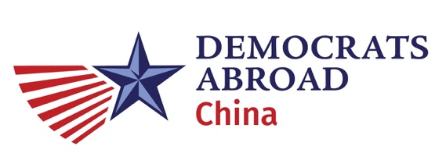

Sunday, 2020.03.22 DACN Leadership Meeting Minutes.
Attendees (noted by Aaron): Aaron Kruse, Alexander Lee, Eileen Walsh, Elaine Chow, Justin Fischer, Patrick Cranley, Faith Gary, Bill Bleisch
Meeting Minutes
Jan & Feb Meeting Minutes - Approved
- GPP Results out tomorrow. 3/23 Evening
- Next Step: Pledge Delegates
- AP has 1 delegate to elect in Milwaukee (now August 2020)
- Each Region proportional to how many ppl participated in
- GPP Delegate Elections happen in May 14th
- Regional Call Next weekend (get notes from someone who attended)
- Primary - We had votes of 400 pax or more
- General Election We can expect 1000 pax or more (Reminder - people need to vote through their state this time, can’t be through DA)
- Volunteer Opportunities ->Create WeChat group for that that is partisan
Important Dates
- 4/3 Need to send out AGM Notice
- 4/17 Deadline to apply to be DA AP delegate (1 position) for 8/17 DNC Meeting
- 5/3 DA China AGM Meeting (In Person Events?)
- 5/14 GPP Delegate Elections- We are electing 1 person from AP Region
- 5/16 AP Regional Meeting
- 6/7 Global Level DA Annual Meeting Only Digital
- 8/17 DNC Meeting in Milwaukee
WeChat Org
- Default - add people into announcements
- Reminder to announce meetings
- WeChat - Elaine to help add people via DA China WeChat
- DA China Chat - Elaine/Aaron will send out message about dissolving. Need to followup on next steps in call before next meeting.
Our Next Call: April 26 8:30PM Details to be sent for Zoom Meeting.

